National Trends related to Bias, Discrimination during COVID-19
  - April 23, 2020

Summary
We have compiled national statistics capturing the impact and frequency of instances of bias and discrimination occurring since the rise of the pandemic. Existing societal inequities are exacerbated during times of crisis, and directly impact the mental and physical health, security, economic, professional, and educational well-being of Harvard community members. Acknowledging and working to thoughtfully address these issues will reinforce our commitment to diversity and display a strong show of support for our most vulnerable community members during this time.

Racist Incident Reports

The stark racial imbalance in coronavirus infections, visualized

Washington Post | April 23, 2020
- Those infected by the coronavirus in the United States tend to be disproportionately black due to various reasons: underlying health conditions, less access to affordable medical care, a higher likelihood of holding jobs deemed “essential” and housing disparities
- Data from the Centers for Disease Control and Prevention shows both how black Americans are afflicted more than other groups — particularly older black Americans.
- 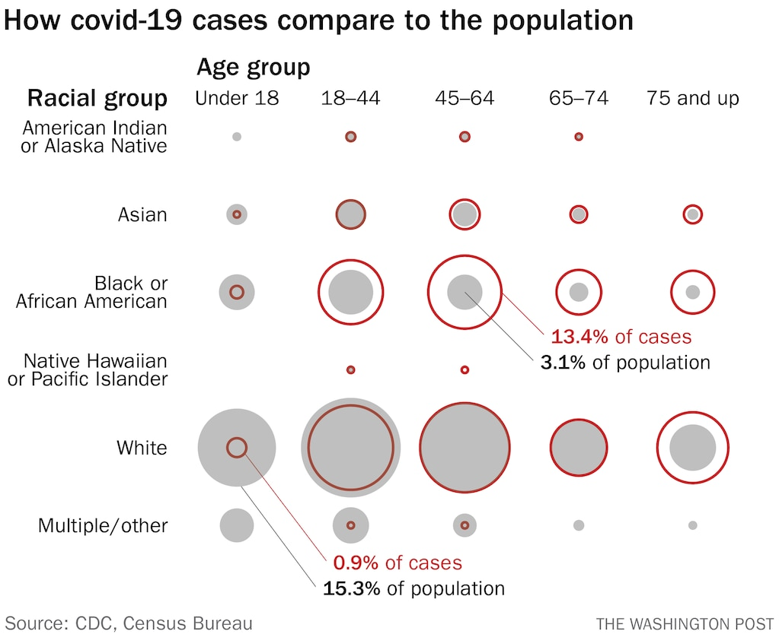
- 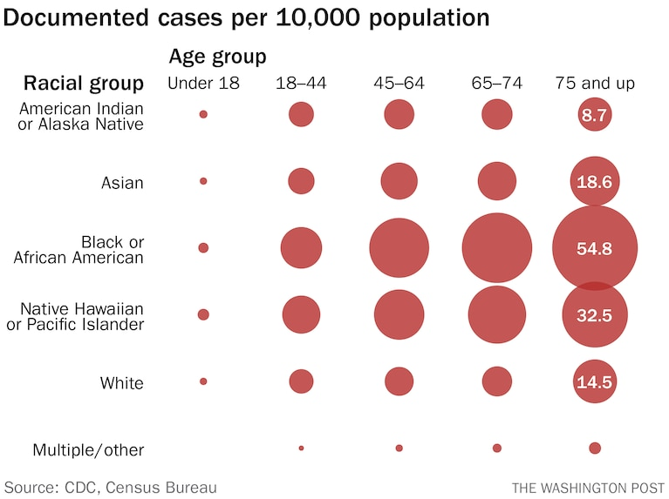

Senators urge anti-bias police training over face mask fears during coronavirus pandemic

CNBC | April 17, 2020
- California senator and other Senate Judiciary Committee members urged law enforcement agencies to provide anti-bias training and guidance to police officers
- People in communities of color express fears of being profiled while wearing masks or other face coverings in public.
- Florida an African American doctor who wore a mask as he volunteered to test homeless people for COVID-19 was handcuffed and detained by police outside his home
- Pennsylvania an African American without a mask was dragged from a bus by transit officers a day after Southeastern PA Transportation Authority began requiring customers to wear facial coverings
- Nearly one-third of those who have died from COVID-19 are black, but African Americans are roughly 14% of the population in the areas included in the analysis.

Black Americans are being hammered by a double pandemic

CNN | April 13, 2020
- For blacks, already more likely to die from HIV/AIDS than any other group in America, it's a double pandemic -- two lethal and incurable viruses hitting at once.
- African Americans make up 13% of the US population but accounted for 42% of new HIV diagnoses in the United States in 2018, according to the Centers for Disease Control and Prevention.

Two black men say they were kicked out of Walmart for wearing protective masks. Others worry it will happen to them.

Washington Post | April 9, 2020
- A recent report of a police officer following young black men who wore masks while shopping has amplified fears among people of color of being profiled as criminals or gang members.
- Civil rights leaders, politicians and community activists worry that concerns of racial bias will discourage black people from wearing masks to protect themselves and others, further increasing their exposure to a virus that is disproportionately infecting and killing African Americans.

Black Americans Face Alarming Rates of Coronavirus Infection in Some States

The New York Times | April 7, 2020
- Louisiana about 70% of the people who have died are African Americans
- Chicago 72% of those who have succumbed to the virus are African American, residents who make up a little less than a third of the population
- North Carolina and South Carolina black residents account for a higher proportion of positive coronavirus tests than they represent in the general population.
- Las Vegas black people are overrepresented compared with white people among those infected.
- California, New Jersey, New York and Washington have not provided statewide info

Social Distancing Is A Privilege

The New York Times | April 5, 2020
- Milwaukee County, Wis. 81% of deaths were black people who make up only 26% of that county
- Michigan at least 40% of those killed by the coronavirus are black, far exceeding the proportion of African Americans in the Detroit region
- One in five black workers and roughly one in six Hispanic workers are able to work from home
- Only 9.2% of workers in the lowest quartile of the wage distribution can telework, compared with 61.5 % of workers in the highest quartile

Why I don’t feel safe wearing a face mask

Boston Globe | April 5, 2020
- A Black man cannot walk into a store with a bandana covering the greater part of my face if I also expect to walk out of that store. The situation isn’t safe and could lead to unintended attention, and ultimately a life-or-death situation for me. For me, the fear of being mistaken for an armed robber or assailant is greater than the fear of contracting COVID-19.

Rabbi Cooper demands Telegram, other social media remove coronavirus posts to ‘kill Jews’

Fox News | April 3, 2020
- New York and New Jersey, Simon Wiesenthal Center, anti-Semitism incidents on the rise, over 1,300 incidents in U.S. in 2019

As Coronavirus Cases Mount, Anti-Asian Hostility Spikes Across The US

WGBH | April 21, 2020
- In March, launched a website called Stop AAPI Hate for individuals to report incidents anonymously, received over 100 incidents a day with accounts of micro-aggressions and strong hate.
- Nationally a survey of Asian-Americans finds 90% fear racial bias and harassment
- Massachusetts accounts for more than 2% (37 cases) of 1,500 national reports
- About 10% of all cases have been physical assaults: stabbed, pushed, shoved

With the spread of coronavirus came a surge in anti-Asian racism online, new research says

CNN | April 10, 2020
- A new study from the Network Contagion Research Institute reports that the coronavirus pandemic has coincided with a surge in Sinophobic (anti-Chinese) sentiments online
- Messages include conspiracy theories about the coronavirus being a bioweapon created by China's government and transmitted by Chinese people.
- On Instagram, a user said he and his friends would shoot Asian people in Chinatown because "that's the only way we can destroy the epidemic."
- NCRI report: "Weaponized Information Outbreak: A Case Study on Covid-19, Bioweapon Myths, and the Asian Conspiracy Meme.”

Asian Americans Report More Than 1K Racist Attacks Since Pandemic, Data Finds

NBC News | April 7, 2020
- Nationally over 1,100 reports of discrimination against primarily Asian Americans recorded since the coronavirus outbreak
- Nearly 100 reports daily, 5.5% from limited-English speakers
- Women are 3x more likely to report harassment than men
- Asians of different ethnicities racially profiled; 61% reports from non-Chinese
- Most common reports on verbal harassment, followed by shunning and physical assault

Asian Americans report over 650 racist acts over last week, new data says

NBC News | March 26, 2020
- Nationally 650 direct reports of discrimination from March 18 to 26 (one week), primarily against Asian Americans
- People coughed at, spat on, trash thrown at them, told to leave stores, refused service at businesses, verbal and online harassment, physical assault
- Nationally +1000 cases of xenophobia against Asian Americans between Jan. 28 and Feb 24. (San Francisco State University)

What’s spreading faster than coronavirus in the US? Racist assaults and ignorant attacks against Asians

CNN | February 21, 2020
- Los Angeles man singles out Thai American on subway to rant how Chinese people are filthy, “every disease has ever came from China.”
- New York multiple beatings in public by men against women who look Chinese
- Indiana Super 8 motel and Days Inn hotel turns away Hmong people after asking “If you’re from China, I need to know”

Despite call for coronavirus survivors to donate plasma, some still being turned away from blood donation

FOX 5 NY | April 19, 2020
- Gay man turned away from New York Blood Center to donate plasma after following a recovery from COVID-19.
- Gay and bisexual men have been prohibited for 37 years from donating blood since the AIDS crisis
- This year, FDA decides gay men who abstained from sex for three months can now donate blood.

Domestic Abuse Reports

Domestic violence has increased during coronavirus lockdowns

The Economist | April 22, 2020
- Chicago, Kansas City, LA, Memphis, New Orleans show that among +100,000 reports from police departments which all went into lockdown between March 19th and 24th, total crime fell about 25% compared with March 1st week, while domestic violence increased by 5%.
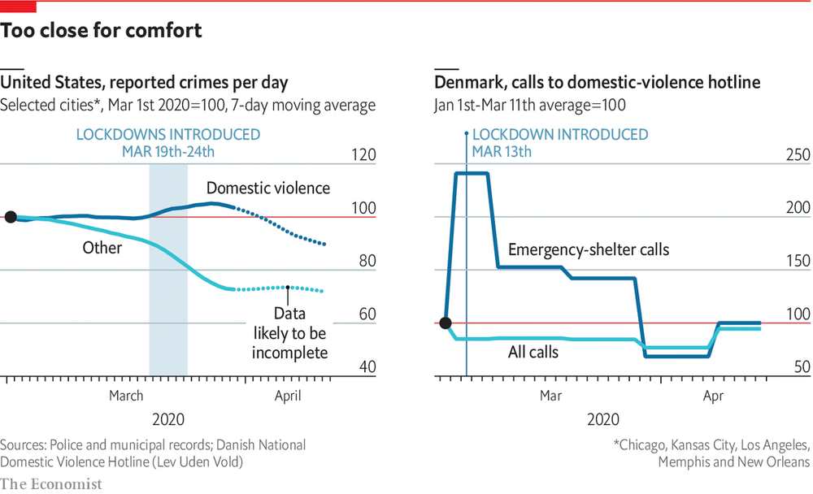

Police see rise in domestic violence calls amid coronavirus lockdown

NBC News | April 5, 2020

- Cherokee County, SC, 35% increase in domestic violence calls in March than February
- Houston, TX, 20% increase
- Charlotte-Mecklenburg, NC, 18% increase
- Phoenix, AZ, 6% increase

In quarantine with an abuser: surge in domestic violence reports linked to coronavirus

The Guardian | April 3, 2020
- Nationally 951 callers for National Domestic Violence Hotline between March 10 and 24 related to Covid-19
- Women hold 2/3 America’s low-wage jobs, and many have been cut causing financial uncertainty
- Reports include manipulation, forced isolation from friends and family, threats, thrown out of the house, verbal and physical violence

Domestic violence victims, stuck at home, are at risk during coronavirus pandemic

CNN | March 27, 2020
- Nationally 3.28 million Americans filed for unemployment this week; unemployment strongly tied to alcohol use disorder, worsens severity and frequency of domestic violence
- Nationally gun sales surging; abuser possession of a firearm makes 5x more likely for victim to be killed
- Oregon child abuse hotline dropped more than 50%, advocates worry children not in classrooms where teachers can report abuse on their behalf

Environmental Reports

'Cancer Alley' Has Some of the Highest Coronavirus Death Rates in the Country

Vice News| April 7, 2020
- Reserve, Louisiana petrochemical plant and others lining 85-mile industrial stretch from New Orleans to Baton Rouge known as “Cancer Alley”
- 2015, EPA found area near Denka plant had the highest risk of air pollution-caused cancer in the country, ~50x the national average
- A COVID-19 vulnerability map launched by healthcare data firm Jvion shows socioeconomic and environmental factors make Cancer Alley communities particularly vulnerable.
- “Disadvantaged communities of color we know have greater exposure to air pollution on average than wealthier white communities,” John Balmes, professor at University of California and national spokesperson for the American Lung Association.
- March, EPA issued a near total suspension of its enforcement of environmental laws, amid pressure from the oil industry, claimed that potential staffing shortfalls during the pandemic would impede ability to meet regulatory requirements.

Disability Reports

Coronavirus deaths reported at state-run facilities for those with mental illness, developmental disabilities

Boston Globe | April 23, 2020
- Boston dozens of confirmed cases of coronavirus among patients and staff in state-run medical centers that serve people with chronic conditions, mental illness, and intellectual disabilities
- Workers have limited supplies of personal protective equipment and lack of training, staff feel scared and unprepared, fearful of their co-workers and patients
- 255-bed Shattuck Hospital, 64 patients and 46 staff had tested positive
- 394-bed Tewksbury Hospital, 87 patients and 104 staff were infected
- 120-member Hogen Center, 47 residents and 90 staff had tested positive
- 220-member Wrentham Developmental Center, fifteen residents and 13 staff were infected

Who Are The Most Likely To Be Saved?': Alice Wong On Living With Disability During COVID-19

WBUR | April 8, 2020
- People with disabilities are concerned about discrimination within the health care system during the COVID-19 pandemic.
- “Before the pandemic, [disabled people] have not been served adequately, and we've been failed by the health system,” she says. “There is such systemic bias and basic access issues to things, such as testing like mammograms or other exams.”

LGBTQ Reports

COVID-19 Sent LBGTQ Students Back to Unsupportive Homes. That Raises the Risk They Won’t Return.

The Chronicle of Higher Education | April 24, 2020
- College campuses can be crucial safe havens for students who spend their childhoods keeping their sexual orientation and gender identity hidden because they live in unsupportive places
- Without campus, LGBTQ students are among the most vulnerable, and at high risk of dropping out
- Nationally 1/5 undergrads identified as something other than heterosexual (30,000 respondents); 2% identified as transgender, nonbinary, non-cisgender
- LGBTQ community is more likely than general population to face financial difficulties and health problems, especially if they lack support from their families – compounding risk that they’ll drop out.

Resources
- Stop AAPI Hate national online discrimination reporting form for Asian Americans & Pacific Islanders (available in English, Chinese, Japanese, Korean, Vietnamese, Thai, Khmer, Punjabi)
- No Time For Hate University of Utah university-wide reporting resource for discrimination during the coronavirus pandemic
- Gender-Based Violence & COVID-19 HKS Gender Action Portal highlights research summaries that may be helpful to policymakers/leaders/others working on the COVID-19 pandemic
- National Domestic Violence Hotline Call 1-800-799-7233 or text LOVEIS to 22522
- National Sexual Assault Hotline 1-800-656-4673
- Crisis Text Line Text HOME to 741741
- Childhelp National Child Abuse Hotline 1-800-422-4453
- Office on Women's Health Helpline 1-800-994-9662

